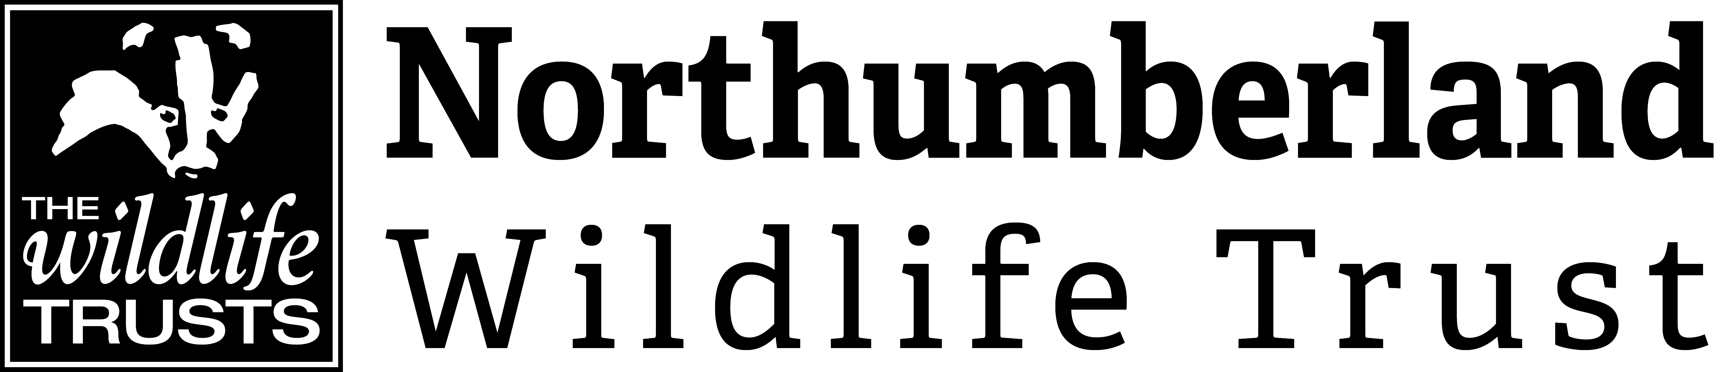

**Chevington Catchment Officer**

Information Pack

**Contact Details:**

Paula Turner (HR and Payroll Officer)

Northumberland Wildlife Trust

St Nicholas Park, Gosforth

Newcastle upon Tyne NE3 3XT

0191 284 6884

[paula.turner@northwt.org.uk](mailto:paula.turner@northwt.org.uk)

**Who we are…**

Northumberland Wildlife Trust was founded in 1971 to protect wildlife and promote nature conservation within Newcastle, North Tyneside and Northumberland. Today, our voice for wildlife is stronger than ever. We are a non-government funded charity, supported by membership, donations, local businesses and charitable trust grants.

**Our vision and strategic objectives**

**A Wilder Future for our area**

We want: Everywhere and everything here Wilder, including people’s lives and jobs, with landscapes richer in wildlife and better-connected land, wetlands and seas.

We want: To reach more people, form more partnerships and play a greater part in wilding and greening locally and contribute globally to restoring nature and tackling climate breakdown.

We will create Wilder Places, Wilder People and a Wilder Future, with more, bigger and better joined up areas for wildlife to thrive, more people taking action and connecting to nature and influencing more decisions to secure nature’s recovery locally, regionally and nationally.

**We will achieve our vision by:**

* Defending wildlife and wild places
* Enabling nature’s recovery: protecting the best and improving the rest
* Inspiring people and communities to care and enabling them to act
* Influencing organisations to behave in nature’s interest
* Growing our resources and partnerships to be more effective and agile

**We will deliver our vision through three key strategic objectives**

1. Lead nature’s recovery
2. Inspire people and organisations to care and mobilise them to act
3. Ensure an agile green culture and sustainable NWT

**We work as part of a national movement…**

There are 46 local Wildlife Trusts across the whole of the UK, the Isle of Man and Alderney, all working for an environment rich in wildlife for everyone.

With 850,000 members, we are the largest UK voluntary organisation dedicated to conserving the full range of the UK’s habitats and species, whether they be in the countryside, in cities, or at sea. 135,000 of our members belong to our junior branch, Wildlife Watch.

We manage 2,300 nature reserves covering more than 80,000 hectares; we stand up for wildlife; we inspire people about the natural world and we foster sustainable living.

All 46 Wildlife Trusts are members of the Royal Society of Wildlife Trusts (RSWT) which operates a separate Grants Unit administering major funds on behalf of the Big Lottery Fund and the Landfill Communities Fund.

To find out more…

[www.nwt.org.uk](http://www.nwt.org.uk)

[www.wildlifetrusts.org](http://www.wildlifetrusts.org)

**Chevington Catchment Officer**

We are looking to appoint a confident, innovative and enthusiastic person to join our Druridge Bay Team

The role is for a 35 hours per week on a 5 month contract.

The salary starts at £22,500 per annum on a grade C1.

**Information for applicants**

To apply for the position of Chevington Catchment Officer, please complete the corresponding Application Form in full, and return it to Paula Turner (contact details on the front of this pack) by the specified deadline.

**Please note, speculative CVs and/or covering letters will not be accepted.**

If you require further information regarding any aspect of the application process, please do not hesitate to get in touch.

Thank you for your interest in Northumberland Wildlife Trust.

**Job specification**

Post title

Chevington Catchment Officer

Location

The post will be based at Druridge Bay

**Responsible to**The post is responsible to Druridge Bay Landscape Manger

**Responsible for**

The post is responsible for trainee staff and volunteers

**Internal relationships**

NWT Staff and volunteer team

**External relationships**

Local landowners, contractors and project partners

**Main responsibilities**

Working with landowners’ permissions to carry out site visits, walkovers and surveys on the Chevington Burn catchment. Develop and deliver initiatives to improve water quality of the Chevington Burn and its tributaries and manage the project budget.

Work within NWT’s Health and Safety as well as other applicable policies while contributing to their development and future implementation. Undertake any other tasks that NWT may reasonable require.

**Salary Band**

Scale C £22,550 - £25,300 per annum.

A further 5% is payable into the Trust’s Stakeholder Pension scheme after three months, conditional on the employee contributing at least 5% of salary.

**Holidays**

22 days basic (pro rata), plus the period between Christmas and New Year and all English bank holidays (pro rata). Where these are worked, time off in lieu is given. After three years’ service, an additional day’s leave will be awarded for each year worked, up to a maximum of 5 (pro rata).

**Hours**

35 hours per week. Evening and weekend work will be required.

NWT operates a flexitime system.

**Travel**

A full UK drivers licence and access to a vehicle is essential to carry out this role. Use of a fleet vehicle may be possible.

**Contract, Probation and Notice**

Fixed Term contract until 31st March 2022. Potential to extent depending on funding.

Probationary period of 4 weeks, minimum of 4 weeks notice required from either party.

**Person specification**

**Knowledge, skills and attributes**

Essential attributes

* Understanding of ecological survey techniques, mainly around water.
* Ecological identification skills.
* Understanding of water catchment improvement methods.
* Hard working and organised. Able to prioritise across multiple work streams and take on tasks from conception to completion.
* Excellent people and influencing skills, able to engage confidently both formally and informally with landowners and managers.
* Excellent team worker but also self-motivated and able to work unsupervised.
* Perceptive of different partner organisation’s needs and delivery responsibilities.
* Thorough understanding and implementation of health and safety and risk assessment procedures.
* Good level of computer literacy and experience of the MS Office suite.
* UK Driving licence and ability to travel across the project area.
* Ability to work evenings and weekends on a regular basis.

Desirable attributes

* A knowledge of the Druridge Bay landscape.
* A good understanding of and enthusiasm for the Wildlife Trusts.

**Experience**

Essential

* Carry out site assessments and surveys for water bodies.
* Experience of working with landowners.
* Knowledge of budgeting and monitoring financial spend.

Desirable

* Experience of working with volunteers.
* Working within the charitable sector.
* Budget management.
* Working with contractors.
* Delivering training to support conservation activities.

**Qualifications**

Essential

* Appropriate academic qualifications or equivalent level of vocational experience.

Desirable

* 1st Aid at work (3 Day)

**Personality**

Essential

* High level of enthusiasm, self-motivation and self-discipline.
* Flexible approach to work, adaptable.
* Willingness to learn new skills.
* Approachable and courteous manner combined with a good sense of humour.
* Good people skills, able to develop strong relationships.