

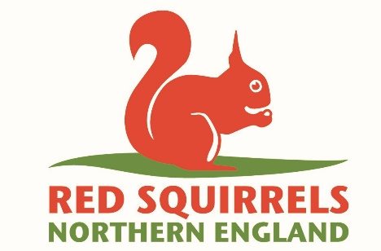

**Red Squirrel Ranger**

Information Pack

**Contact Details:**

Red Squirrel Northern England

C/o Northumberland Wildlife Trust

St Nicholas Park

Gosforth

Newcastle upon Tyne

NE3 3XT

[Info@rsne.org.uk](mailto:Info@rsne.org.uk)

0191 284 6884

**Who we are…**

Northumberland Wildlife Trust was founded in 1971 to protect wildlife and promote nature conservation within Newcastle, North Tyneside and Northumberland. Today, our voice for wildlife is stronger than ever. We are a non-government funded charity, supported by membership, donations, local businesses and charitable trust grants.

**Our vision and strategic objectives**

**A Wilder Future for our area**

We want: Everywhere and everything here Wilder, including people’s lives and jobs, with landscapes richer in wildlife and better-connected land, wetlands and seas.

We want: To reach more people, form more partnerships and play a greater part in wilding and greening locally and contribute globally to restoring nature and tackling climate breakdown.

We will create Wilder Places, Wilder People and a Wilder Future, with more, bigger and better joined up areas for wildlife to thrive, more people taking action and connecting to nature and influencing more decisions to secure nature’s recovery locally, regionally and nationally.

**We will achieve our vision by:**

* Defending wildlife and wild places
* Enabling nature’s recovery: protecting the best and improving the rest
* Inspiring people and communities to care and enabling them to act
* Influencing organisations to behave in nature’s interest
* Growing our resources and partnerships to be more effective and agile

**We will deliver our vision through three key strategic objectives**

1. Lead nature’s recovery
2. Inspire people and organisations to care and mobilise them to act
3. Ensure an agile green culture and sustainable NWT

**We work as part of a national movement**

There are 46 local Wildlife Trusts across the whole of the UK, the Isle of Man and Alderney, all working for an environment rich in wildlife for everyone.

With 850,000 members, we are the largest UK voluntary organisation dedicated to conserving the full range of the UK’s habitats and species, whether they be in the countryside, in cities, or at sea. 135,000 of our members belong to our junior branch, Wildlife Watch.

We manage 2,300 nature reserves covering more than 80,000 hectares; we stand up for wildlife; we inspire people about the natural world and we foster sustainable living.

All 46 Wildlife Trusts are members of the Royal Society of Wildlife Trusts (RSWT) which operates a separate Grants Unit administering major funds on behalf of the Big Lottery Fund and the Landfill Communities Fund.

To find out more…

[www.nwt.org.uk](http://www.nwt.org.uk)

[www.wildlifetrusts.org](http://www.wildlifetrusts.org)

www.rsne.org.uk

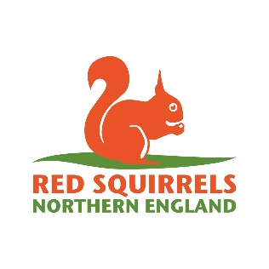

**Red Squirrel Ranger**

The Trust and its trading subsidiary employ 60 staff and work from premises in Gosforth. As an organisation we strongly value our personnel and are committed to continuous improvement in our Conservation work. We are looking for a confident, innovative and enthusiastic person to join our Red Squirrel Project Team. The post-holder will work for the Red Squirrels Northern England (RSNE) project and will be employed by Northumberland Wildlife Trust.

We are looking for an individual with a variety of skills who can carry out grey squirrel management with high levels of competency. The successful candidate will also possess great people skills, be computer literate, and will need to work with and train local community volunteers to help with both grey squirrel control and red and grey squirrel monitoring.

If you have experience of this type of work, and you would like the opportunity to work in a dynamic, friendly and forward-looking organisation then this may be the perfect job for you.

The role is offered initially as a 9 month contract and is for 35 hours a week, with the potential of renewal dependant on securing funding.

Deadline to submit applications is **midday** on, **25th April 2025** and we expect interviews to take place the week commencing the 5th May.

**Information for applicants**

To apply for the position of Red Squirrel Ranger, please complete the corresponding Application Form in full, stating your experience and how you meet the job specification, and return it to the contact details on the front of this pack by the specified deadline.

Please note, speculative CVs and/or covering letters will not be accepted.

If you require any further information, please do not hesitate to get in touch.

Thank you for your interest in Northumberland Wildlife Trust.

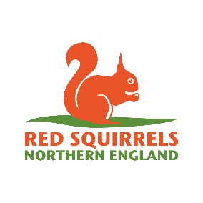

**Job specification**

Post title

Red Squirrel Ranger

Location

Home and field-based, using your own transport – a mileage allowance is payable at 45p per mile for travel within the project area (see appendix One).

**Responsible to**Red Squirrels Northern England Project Manager

**Responsible for**

The delivery of grey squirrel control and red and grey squirrel monitoring in a defined geographical area. Working closely with local communities, helping to support and train volunteers in red squirrel conservation activities.

**Contract Duration**

9 months

**Internal relationships**

* RSNE project team
* Northumberland Wildlife Trust (NWT) teams

**External relationships**

* Project partners and local red squirrel conservation groups
* Members of the public and local community groups

**Direct responsibilities**

* To carry out grey squirrel control in specific woodlands within a defined geographical area (appendix one), this will mainly be using live capture traps and dispatch.
* To carry out field surveys using trail cameras and other methods to establish ongoing monitoring of red squirrels within the area
* Record all activity data using mobile device and provide monthly progress reports
* Engage with local communities (especially local red squirrel conservation groups) to maintain and expand collaborative approaches to red squirrel conservation.
* Support existing and new volunteers, and provide training in red squirrel conservation techniques
* Work with landowners and managers within the project area to gain access to land, and secure their continued cooperation in the project, working closely with the RSNE Area Ranger and Project Manager to develop and nurture these relationships.

**General responsibilities**

* To support financial sustainability and green action across all areas of the Trust
* To undertake any other tasks which the Trust may reasonably require
* To work within the Trust’s policy framework, with particular attention to health & safety and lone working policies.

**Indirect responsibilities**

* To report to stakeholder groups as required

**Salary band**

Scale starts at £22,470 pro rata

**Contribution to personal pension**

5% of salary conditional on 5% being paid by pension holder.

**Holidays**

22 days per year (Pro Rata), plus bank holidays, discretionary days at Christmas and 5 additional days awarded in stages after 3 years’ service.

**Hours**

The post-holder will be expected to work an average of 35 hours per week.

**Car & travel**

Own vehicle should be provided (with insurance for business use), a valid full driving licence is required for which mileage and maintenance contribution is paid in arrears.

**Contract, probation & notice**

Contract length is for 9 months

Probation review after 1 month

1 months’ notice required

**Person specification**

**Knowledge, skills & attributes**

Essential

* Demonstrable understanding and experience of practical conservation skills, with extensive experience of working in the countryside in a variety of conditions.
* Experience of formulating and delivering grey squirrel management plans, including operating live capture traps, and the use of humane dispatch techniques, including shooting and cranial dispatch.
* Experience of building and maintaining professional relationships with members of the public and landowners.
* Good communication skills and confidence working with local communities, helping to deliver training and support to volunteers and land managers
* Ability to work effectively and professionally with landowners and managers
* Knowledge of wildlife issues and law relating to wildlife
* Good working knowledge of using mobile devices/apps for data collection, and meticulous skills in recording data in the field, including use of GPS.
* Ability to work efficiently on their own, and as part of a team.

Desirable

* Experience of using technology in the field, including trail and thermal imaging cameras.
* Confidence and experience in handling firearms and hold all current relevant certificates.
* Experience of using GIS systems (such as QGIS and ArcGIS).
* Outdoor First Aid qualification (First aid +F).
* Confident using word processing and Excel spreadsheets to record and present information.

**Other Information**

Training: Additional training will be provided to ensure best practice, and the successful candidate will spend time in the field with other rangers to ensure most efficient working practices are used.

Equipment: Trapping materials and PPE will be provided. Transport and firearms (if required) will need to be supplied by the successful candidate.

**Personality**

* Excellent communicator, able to work across a range of audiences
* Enthusiastic and friendly
* Highly-motivated and adaptable
* Sensitive to countryside management issues and ability to maintain confidential contract information.
* Strong desire to achieve team goals and objectives.

Appendix One: Ranger project area

