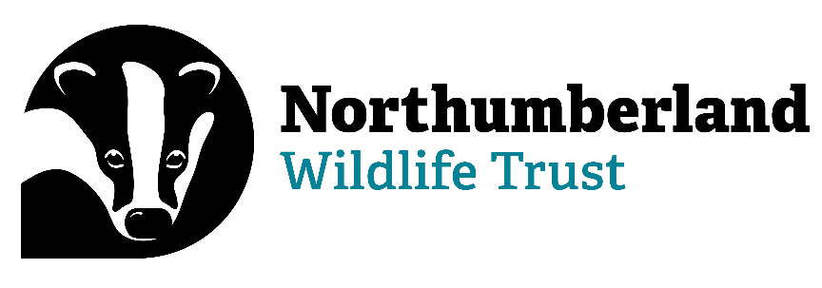

**Conservation Assistant**

Information Pack

**Contact Details:**

Paula Turner (HR and Payroll Officer)

Northumberland Wildlife Trust

St Nicholas Park, Gosforth

Newcastle upon Tyne NE3 3XT

0191 284 6884

[paula.turner@northwt.org.uk](mailto:paula.turner@northwt.org.uk)

**Who we are…**

Northumberland Wildlife Trust was founded in 1971 to protect wildlife and promote nature conservation within Newcastle, North Tyneside and Northumberland. Today, our voice for wildlife is stronger than ever. We are a non-government funded charity, supported by membership, donations, local businesses and charitable trust grants.

**Our vision and strategic objectives**

**A Wilder Future for our area**

We want: Everywhere and everything here Wilder, including people’s lives and jobs, with landscapes richer in wildlife and better-connected land, wetlands and seas.

We want: To reach more people, form more partnerships and play a greater part in wilding and greening locally and contribute globally to restoring nature and tackling climate breakdown.

We will create Wilder Places, Wilder People and a Wilder Future, with more, bigger and better joined up areas for wildlife to thrive, more people taking action and connecting to nature and influencing more decisions to secure nature’s recovery locally, regionally and nationally.

**We will achieve our vision by:**

* Defending wildlife and wild places
* Enabling nature’s recovery: protecting the best and improving the rest
* Inspiring people and communities to care and enabling them to act
* Influencing organisations to behave in nature’s interest
* Growing our resources and partnerships to be more effective and agile

**We will deliver our vision through three key strategic objectives**

1. Lead nature’s recovery
2. Inspire people and organisations to care and mobilise them to act
3. Ensure an agile green culture and sustainable NWT

**We work as part of a national movement**

There are 46 local Wildlife Trusts across the whole of the UK, the Isle of Man and Alderney, all working for an environment rich in wildlife for everyone.

With 850,000 members, we are the largest UK voluntary organisation dedicated to conserving the full range of the UK’s habitats and species, whether they be in the countryside, in cities, or at sea. 135,000 of our members belong to our junior branch, Wildlife Watch.

We manage 2,300 nature reserves covering more than 80,000 hectares; we stand up for wildlife; we inspire people about the natural world and we foster sustainable living.

All 46 Wildlife Trusts are members of the Royal Society of Wildlife Trusts (RSWT) which operates a separate Grants Unit administering major funds on behalf of the Big Lottery Fund and the Landfill Communities Fund.

To find out more…

[www.nwt.org.uk](http://www.nwt.org.uk)

[www.wildlifetrusts.org](http://www.wildlifetrusts.org)

**Equality, Diversity and Inclusion (EDI) and Safeguarding:**

Northumberland Wildlife Trust believes that everyone should have the opportunity to experience the joy of wildlife in their daily lives, that’s why we’re committed to putting equality, diversity and inclusion at the heart of our movement.

For more information, please see Our commitment to Equality, Diversity & Inclusion (EDI) | The Wildlife Trusts

For more information about our safeguarding commitment, please see Safeguarding Commitment Statement_0.pdf (wildlifetrusts.org

**Nature Recovery Team**

The Nature Recovery Team sits in the wider Conservation Team and is responsible for delivering nature recovery on land not owned by Northumberland Wildlife Trust. The team delivers land advice and support through the Wilder Northumberland Network, deliver practical conservation on partner sites and works on species recovery projects. Other elements of the team’s role include responding to public enquiries, responding to planning applications, management of the Local Site system and data requests. The team also support the other teams within Northumberland Wildlife Trust with ecological advice and surveys.

**Job title**

Conservation Assistant

**Information for applicants**

To apply for the position of **Conservation Assistant**, please complete the corresponding Application Form in full, and return it to me (contact details on the front of this pack) by the specified deadline.

**Please note, CVs and/or covering letters will not be accepted.**

If you require further information regarding any aspect of the application process, please do not hesitate to get in touch.

Thank you for your interest in Northumberland Wildlife Trust.

**Job specification**

Post title

Conservation Assistant

Location

The post will be based at St Nicholas Park, Gosforth, with some home working. The post-holder will be expected to attend meetings and various other activities (including ecological surveys) across the working area of the organisation. A flexible working arrangement will be agreed with the line-manager upon appointment.

**Responsible to**   
Conservation Officer

**Responsible for**

* Volunteers.

**Internal relationships**

* Nature Recovery Team
* Wild City Team
* Estates Team
* NWT Volunteers

**External relationships**

* Partner organisations e.g. conservation NGOs, statutory bodies, local authorities
* Members of the public

**Job role**

To support the Conservation Officer with their work including the responsibilities below, as well as to support other members of the Nature Recovery Team when required.

**Main responsibilities**

* Carrying out/assisting with ecological surveys
* Facilitating and updating the Local Wildlife Site system & data enquiry service
* Helping colleagues across NWT deliver conservation value in projects
* Assisting with the development of conservation projects and/or funding bids
* Assisting with bidding for and delivering conservation-related contracts
* Responding to planning applications
* Working with volunteers, including student placements, to deliver conservation activity for NWT
* Responding to enquiries from members of the public
* Attending meetings on behalf of the Trust
* Supporting financial sustainability and green action across all areas of the Trust
* Undertake other work as required by managers

**Other responsibilities**

* To act as an advocate for NWT and its values.
* Attend NWT/partner staff, departmental and supervisory meetings as needed.

**Salary band**

Scale B - Starting on B1 £22,470

**Contribution to personal pension**

5% of salary conditional on 5% being paid by pension holder and after probationary period

**Holidays**

22 days per year, plus discretionary days at Christmas and one extra day per year of work after 5 years up to 5 extra days.

**Hours**

The post is full time (35 hours/week). This is normally Monday to Friday but some evening and weekend work may be required

**Car & travel**

Full Driving licence is essential; Fleet vehicles available and access to own transport deirable, for which mileage is reimbursed.

**Contract, probation & notice**

The job is offered until 30/09/2026. Potential for extension dependant on funding. There is a probationary period of 6 months.

A minimum of 4 weeks’ notice is required from either party.

**Person specification**

**Knowledge & attributes**

Essential

* Knowledge of nature conservation and wildlife
* Good ICT skills (fully conversant with Microsoft Office)
* Basic GIS skills, including QGIS and AGOL
* Ability to work independently and as part of a team
* Good face-to-face and written communication skills
* Current driving licence

Desirable

* Good identification skills of British wildlife
* Good understanding of wildlife conservation practices
* Understanding of wildlife survey techniques and familiarity with equipment used

**Skills & experience**

Essential

* Carrying out ecological surveys of habitats or species
* Communicating with a wide range of audiences

Desirable

* Working with volunteers
* Responding to/assessing planning applications

**Qualifications**

Essential

* Degree in a relevant subject, or equivalent experience

**Personal**

Essential

* Excellent communicator able to build working relationships with a range of audiences
* Excellent team player with proven skills in collaboration and supporting a wider team
* Be self-motivated, a good organiser and the ability to deliver within agreed timescales
* Positive attitude to work focused on solutions and making things happen