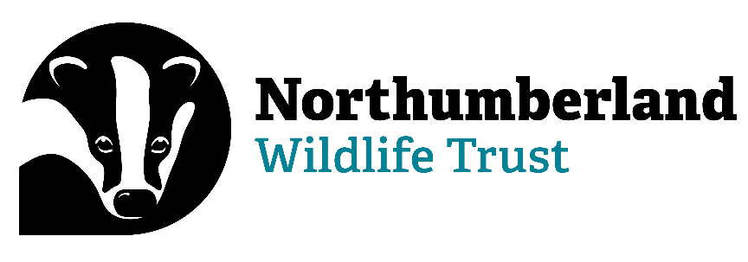

**Estates Assistant**

Information Pack

**Contact Details:**

Paula Turner (HR and Payroll Officer)

Northumberland Wildlife Trust

St Nicholas Park, Gosforth

Newcastle upon Tyne NE3 3XT

0191 284 6884

[paula.turner@northwt.org.uk](mailto:paula.turner@northwt.org.uk)

**Who we are…**

Northumberland Wildlife Trust was founded in 1971 to protect wildlife and promote nature conservation within Newcastle, North Tyneside and Northumberland. Today, our voice for wildlife is stronger than ever. We are a non-government funded charity, supported by membership, donations, local businesses and charitable trust grants.

**Our vision and strategic objectives**

**A Wilder Future for our area**

We want: Everywhere and everything here Wilder, including people’s lives and jobs, with landscapes richer in wildlife and better-connected land, wetlands and seas.

We want: To reach more people, form more partnerships and play a greater part in wilding and greening locally and contribute globally to restoring nature and tackling climate breakdown.

We will create Wilder Places, Wilder People and a Wilder Future, with more, bigger and better joined up areas for wildlife to thrive, more people taking action and connecting to nature and influencing more decisions to secure nature’s recovery locally, regionally and nationally.

**We will achieve our vision by:**

* Defending wildlife and wild places
* Enabling nature’s recovery: protecting the best and improving the rest
* Inspiring people and communities to care and enabling them to act
* Influencing organisations to behave in nature’s interest
* Growing our resources and partnerships to be more effective and agile

**We will deliver our vision through three key strategic objectives**

1. Lead nature’s recovery
2. Inspire people and organisations to care and mobilise them to act
3. Ensure an agile green culture and sustainable NWT

**We work as part of a national movement**

There are 46 local Wildlife Trusts across the whole of the UK, the Isle of Man and Alderney, all working for an environment rich in wildlife for everyone.

With 850,000 members, we are the largest UK voluntary organisation dedicated to conserving the full range of the UK’s habitats and species, whether they be in the countryside, in cities, or at sea. 135,000 of our members belong to our junior branch, Wildlife Watch.

We manage 2,300 nature reserves covering more than 80,000 hectares; we stand up for wildlife; we inspire people about the natural world and we foster sustainable living.

All 46 Wildlife Trusts are members of the Royal Society of Wildlife Trusts (RSWT) which operates a separate Grants Unit administering major funds on behalf of the Big Lottery Fund and the Landfill Communities Fund.

To find out more…

[www.nwt.org.uk](http://www.nwt.org.uk)

[www.wildlifetrusts.org](http://www.wildlifetrusts.org)

**Information for applicants**

To apply for the position of Estates Assistant, please complete the corresponding Application Form in full, and return it to me (contact details on the front of this pack) by the specified deadline.

**Please note, CVs and/or covering letters will not be accepted.**

If you require further information regarding any aspect of the application process, please do not hesitate to get in touch.

Thank you for your interest in Northumberland Wildlife Trust.

**Job title**

Estates Assistant

**Job specification**

Post title

Estates Assistant

Location

The post will be based at St Nicholas Park, Gosforth.

**Responsible to**Estates Manager

**Responsible for**

* Volunteers
* Placements

**Internal relationships**

* Estates team
* Other teams as required.
* Trustees
* Volunteers

**External relationships**

* Project partners
* External land owners and managers, as directed by the Estates Manager
* External contractors and service providers, as directed by the Estates Manager
* Members of public
* Any other stakeholders, as appropriate and directed by the Estates Manager

**Job role**

* To help deliver land management across NWT’s range of nature reserves, on land the Trust manages and other land, where directed by the Estates Manager
* To assist with and lead volunteers undertaking management of sites.
* To work with the Estates and Nature Recovery teams, and other staff members within NWT as appropriate, to deliver monitoring and survey where required

**Main responsibilities**

* Work closely with team colleagues to deliver habitat management on NWT nature reserves, and land managed by NWT
* Assist colleagues to lead and support volunteers carrying out habitat management and improving access/interpretation, ensuring safe working and accurate data recording, also deliver ecological surveys where directed.
* Oversee placement and volunteer staff as directed
* Ensure all policies and procedures associated with Health & Safety are followed.
* Ensure all other NWT policies and procedures are followed
* Ensure all activities comply with UK wildlife legislation
* Record and file survey data electronically, as per agreed methodologies
* Assist the Estates Manager/ team colleagues with overseeing contractor delivery
* Assist the Marketing team in keeping digital communications and social media (Facebook, Twitter, Instagram, project blog, website) up to date (contribute photographs/stories of wildlife sightings/ management activities)
* Assist the Nature Recovery team on management of other sites outside NWT’s land holding where necessary and as agreed by the Estates Manager
* Work with colleagues to ensure proper use and maintenance of tools and equipment, and supply of necessary resources and materials.
* Undertake other work as required
* Share in NWT’s philosophy, participate as a full member of NWT and support initiatives across the whole organisation as appropriate.

**Other responsibilities**

* To act as an advocate for NWT and its values
* To contribute to team responsibilities
* To attend NWT meetings as required
* Undertake other work as required.

**Salary band**

Scale B starting on C1 £22,470 per annum

**Contribution to personal pension**

5% of salary conditional on 5% being paid by pension holder and after probationary period.

**Holidays**

22 days basic (pro rata), plus the period between Christmas and New Year and all English bank holidays (pro rata). Where these are worked, time off in lieu is given. After three years’ service, an additional day’s leave will be awarded for each year worked, up to a maximum of 5 (pro rata)

**Hours**

35 hours per week with some evening and weekend working required.

NWT operates a flexitime system.

**Car & travel**

A full driving licence is required. Pool vehicles are available for staff use. Mileage and subsistence are paid for use of own vehicle where necessary.

**Contract, probation & notice.**

The post is offered as an initial 3 year contract. The probation period is 6 months. One month’s notice period is required.

**Person specification**

**Knowledge, skills & attributes**

Essential

* Ability to travel widely throughout Northumberland, including to remote rural locations
* Good verbal and written communication skills (Good command of written English)
* Good ICT skills (fully conversant with Microsoft Office) including data handling
* Ability to work independently and as part of a multi-disciplinary team
* Good awareness of health and safety and knowledge of risk assessment/safe use of tools

Desirable

* Interest in and commitment to nature conservation
* Good knowledge of British wildlife identification

**Experience**

Essential

* Experience of a wide range of land management techniques, e.g. fencing, invasive species control, grassland management
* Experience with working with volunteers and managing volunteer teams
* Ability to work with and enthuse people from a wide range of backgrounds

Desirable

* Experience of site management for nature conservation
* Outdoor First Aid

**Qualifications**

Essential

* Qualifications in land based subjects with particular emphasis on the use of machinery such as chainsaw, brush-cutter etc.
* Full current driving licence

Desirable

* Industry qualifications relevant to the role (atv, tractor, 1st Aid etc.)
* Relevant degree or equivalent experience
* Licence to tow trailers up to 3500kg

**Personality**

Essential

* Outgoing, enthusiastic and friendly
* Excellent communicator
* Highly–motivated
* Flexible approach to work
* Team player
* Positive attitude to work
* Able to carry out practical tasks which are physically demanding in a remote and inhospitable environment
* Committed to the principles of the Wildlife Trust (creating a natural/wild landscape, delivering ecosystem services, engaging volunteers and the wider public, inspiring people about nature
* Good team worker but also self-motivated and happy to work alone.