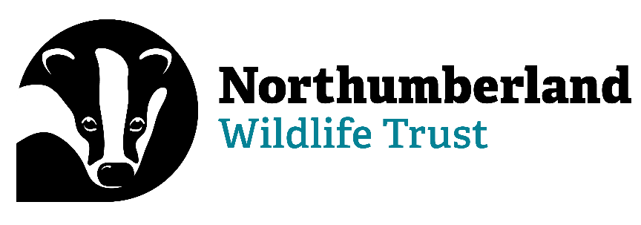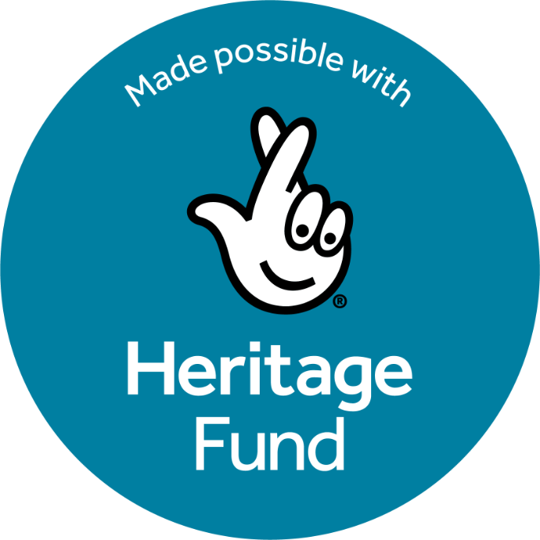



Red Squirrel Recovery Network
Project Assistant
(early career role)

Information Pack

Contact Details:
Paula Turner (HR and Payroll Officer)
Northumberland Wildlife Trust
St Nicholas Park, Gosforth
Newcastle upon Tyne NE3 3XT
0191 284 6884
paula.turner@northwt.org.uk
Who we are…

Northumberland Wildlife Trust was founded in 1971 to protect wildlife and promote nature conservation within Newcastle, North Tyneside and Northumberland. Today, our voice for wildlife is stronger than ever. We are a non-government funded charity, supported by membership, donations, local businesses and charitable trust grants.

Our vision and strategic objectives

A Wilder Future for our area

We want: Everywhere and everything here Wilder, including people’s lives and jobs, with landscapes richer in wildlife and better-connected land, wetlands and seas.

We want: To reach more people, form more partnerships and play a greater part in wilding and greening locally and contribute globally to restoring nature and tackling climate breakdown.

We will create Wilder Places, Wilder People and a Wilder Future, with more, bigger and better joined up areas for wildlife to thrive, more people taking action and connecting to nature and influencing more decisions to secure nature’s recovery locally, regionally and nationally.

We will achieve our vision by:
- Defending wildlife and wild places
- Enabling nature’s recovery: protecting the best and improving the rest
- Inspiring people and communities to care and enabling them to act
- Influencing organisations to behave in nature’s interest
- Growing our resources and partnerships to be more effective and agile

We will deliver our vision through three key strategic objectives
- Lead nature’s recovery
- Inspire people and organisations to care and mobilise them to act
- Ensure an agile green culture and sustainable NWT

We work as part of a national movement

There are 46 local Wildlife Trusts across the whole of the UK, the Isle of Man and Alderney, all working for an environment rich in wildlife for everyone.

With 945,000 members, we are the largest UK voluntary organisation dedicated to conserving the full range of the UK’s habitats and species, whether they be in the countryside, in cities, or at sea. 135,000 of our members belong to our junior branch, Wildlife Watch. We have over 33,000 volunteers, 4,100 staff and 600 trustees.

We manage 2,600 nature reserves covering more than 80,000 hectares; we stand up for wildlife; we inspire people about the natural world and we foster sustainable living.

All 46 Wildlife Trusts are members of the Royal Society of Wildlife Trusts (RSWT) which operates a separate Grants Unit administering major funds on behalf of the Big Lottery Fund and the Landfill Communities Fund.

To find out more…

www.nwt.org.uk
www.wildlifetrusts.org

Equality, Diversity and Inclusion (EDI) and Safeguarding:
Northumberland Wildlife Trust believes that everyone should have the opportunity to experience the joy of wildlife in their daily lives, that’s why we’re committed to putting equality, diversity and inclusion at the heart of our movement.

For more information, please see Our commitment to Equality, Diversity & Inclusion (EDI) | The Wildlife Trusts

For more information about our safeguarding commitment, please see Safeguarding Commitment Statement_0.pdf (wildlifetrusts.org)

Disability Confident Committed:
We aim to offer an interview to disabled people who meet the minimum criteria (e.g. Essential skills). This is to encourage positive action. It is important to note that there may be occasions where it is not practicable or appropriate to interview all disabled people that meet the minimum criteria for the job. For example, if there are a high volume of applications. In these circumstances the employer could select the disabled candidates who best meet the minimum criteria for the job rather than all of those that meet the minimum criteria, as they would do for non-disabled applicants.

Job title

RSRN Project Assistant (early career role)

Information for applicants

To apply for the position of RSRN Project Assistant (early career role), please complete the corresponding Application Form in full, and return it to me (paula.turner@northwt.org.uk) by 9am on the 16th November 2026.

Please note, CVs and/or covering letters will not be accepted.

If you require further information regarding any aspect of the application process, please do not hesitate to get in touch.

Interviews are planned for the 14th December at our main office in Gosforth, Newcastle-upon-Tyne, with an intended start date of the 5th January 2027.

Thank you for your interest in Northumberland Wildlife Trust.

Job specification

Post title
RSRN Project Assistant (early career role)

Location
Northumberland Wildlife Trust (based at St Nicholas Park, Gosforth, Newcastle-Upon-Tyne)

These roles are not entirely office-based jobs. It is expected that up to 50% of the role will be based out in the field, working alongside RSRN project staff or other staff within the host organisation. There may be some opportunity to work from home and there will also be a requirement to occasionally travel to attend training or to visit other organisations within the RSRN.
Responsible to
RSRN Project Officer/Community Engagement Officer, depending on the interest area.
Responsible for
- N/A

Internal relationships
- Staff and volunteers within the host organisation
- RSRN project staff based at other organisations
- Other RSRN Project Assistants

External relationships
- Community organisations, groups and volunteers
- Members of the public

Job role
The Red Squirrel Recovery Network (RSRN) is a partnership between organisations working in northern England and southern Scotland to conserve, protect and celebrate red squirrels. Together we are working towards safeguarding the species, raising awareness and supporting more people to take action to help red squirrels.

The RSRN Project Assistant is an early career role designed to give more people the chance to have a career in the conservation sector. This role comes with a generous training budget and will provide opportunities to develop skills and experience as part of a conservation project. The postholder will be expected to support a wide range of activities, working alongside and supported by Project Officers and Community Engagement Officers. These activities will include supporting volunteer activities, ecological surveys and field work, community events and education workshops, digital events and social media, data analysis.

Main responsibilities
The RSRN Project Assistant will:
- Assist with community events and other education/engagement activities
- Work with the RSRN Project Officer to support local volunteers by providing information, organising training, and facilitating meetings
- Support local volunteers to complete and submit their monitoring results from the annual spring survey
- Assist with project communications and digital awareness, including social media
- Develop skills in all aspects of the project, with additional opportunities to work within other areas of the host organisation to gain a wider breadth of skills and experiences
- Represent RSRN, red squirrel conservation and the host organisation at meetings, events, conferences/seminars, networking events and other activities (both face to face and virtual)
- Participate fully in all aspects of the RSRN training programme
- Contribute to project monitoring and evaluation, including developing a personal portfolio, providing feedback to the project evaluation and producing reports to fulfil funder/partner requirements
- Observe the host organisation’s working policies at all times, including those on Health & Safety, Safeguarding, and Equality, Diversity & Inclusion
- Assist with any other additional duties that may reasonably arise from time to time

It is expected that by the end of the 10 month contract, the RSRN Project Assistant will have:
- Completed their Personal Development Plan, including undertaking training and broadening their work experience
- Participated in a variety of project activities
- Demonstrated skill acquisition in different areas
- Increased independence within their role
- Produced a personal portfolio
- Have a clear idea of their next steps (beyond RSRN)

Other responsibilities
- Attend all necessary NWT and partner staff, departmental and supervisory meetings
- Support delivery and development of NWT strategy, policies – working towards wider organisational goals as well as RSRN programme outcomes

Salary band
National Living Wage
Age 21+: £12.71 from 1st April 2026
Age 18 – 20: £10.85 from 1st April 2026
This will rise in April 2027 in line with current guidelines.

Contribution to personal pension
A further 5% is payable into the Trust's Stakeholder Pension Scheme after three months, conditional on the employee contributing at least 5% of salary.

Holidays
Holidays are calculated based on a full-time entitlement of 22 days per year (plus bank holidays). For the RSRN Project Assistant, holidays will be pro-rata depending on hours (e.g. 28 hours per week will be entitled to 17.6 days’ holiday plus 6.4 bank holidays; 21 hours per week will be entitled to 13.2 days’ holiday plus 4.8 bank holidays). All posts are also entitled to additional discretionary days at Christmas

Hours
21-28 hours per week for 10 months, January – October 2027
NWT operates a flexitime system. The post holder will be expected to work hours according to the needs of the communities that are being engaged. Regular evening, weekend and bank holiday working is expected.

Driving and travel
While a driving licence would be beneficial, it is not required for this role.

Contract, probation & notice
The post is offered as a single 10-month contract.
There is a probationary period of 5 months.
A minimum of 4 weeks' notice is required from either party.
This post will be subject to a DBS check.

Person specification

Knowledge & attributes

Essential
- A genuine interest in the role and the work of the Red Squirrel Recovery Network

Desirable
- Knowledge of the red squirrel or other UK species and habitats
- Awareness of current environmental issues or campaigns
- Awareness of the need for equality, diversity and inclusion when working with different audiences
- Understanding of the importance of volunteers and community participation in conservation
- Interest in citizen science, wildlife monitoring and data recording

Skills & experience

Essential
- Good communication skills (written and verbal)
- Good at working as part of a team
- A desire and commitment to gain practical, ‘on the job’, skills and experience
- Commitment to timekeeping and self-discipline (including the ability to work independently on a set task and meet deadlines)
- Confident using IT, including email and word processing

Desirable
- Experience of working or volunteering in the environment sector
- Experience of organising and delivering events
- Experience of using social media in a professional or volunteering capacity

Qualifications
There is no requirement to have any particular qualifications for this role. We value a desire to learn and commitment the post.

We are an equal opportunity organisation and are committed to the promotion of equality, diversity and inclusion. Our mission is to welcome everyone, to celebrate difference, and we encourage everyone to join us and be themselves regardless of: age, disability, race, religion or belief, sexual orientation, gender identity, marital status or pregnancy and maternity.

We welcome applications from people who are disabled or neurodivergent and we will be happy to discuss any additional support or adjustments needed. We are committed to diversifying our workforce and we will prioritise applications from people who demonstrate that this opportunity will enable them to develop skills/experience and overcome barriers to enable them to access a career in the conservation sector.

Personality

Essential
- Be warm, friendly and polite
- A willingness to take part in activities outdoors and in all weathers
- Be enthusiastic with a positive approach to learning
- Be flexible and adaptable being able to respond to changing project needs positively

Desirable
- Be confident meeting new people, speaking to groups and representing the project at events
- Bring creativity and contribute ideas for engagement and communications activities

